Sreya Kalyan
April 13, 2024
Prof. Keith Paarporn
CS 2160 – Mon/Wed (12:15pm)

Homework 5 Document
Problem 1 (10 pts)
Provide the truth table for a two-input exclusive OR function. Then express it as a Boolean function in both SOP and POS forms.

Truth Table:

A | B | A XOR B
0 | 0 | 0
0 | 1 | 1
1 | 0 | 1
1 | 1 | 0

Sum of Products (SOP) Form:

- A XOR B = (A’ * B) + (A * B’)

Product of Sums (POS) Form:

- A XOR B = (A + B) * (A’ + B’)

Problem 2 (10 pts)
In class, we showed how to build an AND, OR, and NOT gate using only NAND gates. Prove that the NOR gate is universal by showing how to build an AND, OR, and NOT gate using only NOR gates. Provide a diagram for each implementation.

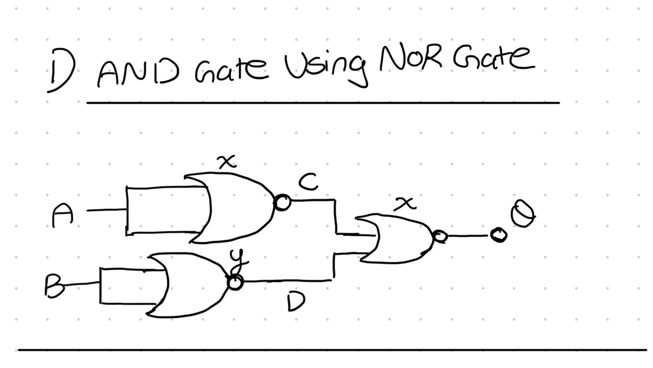

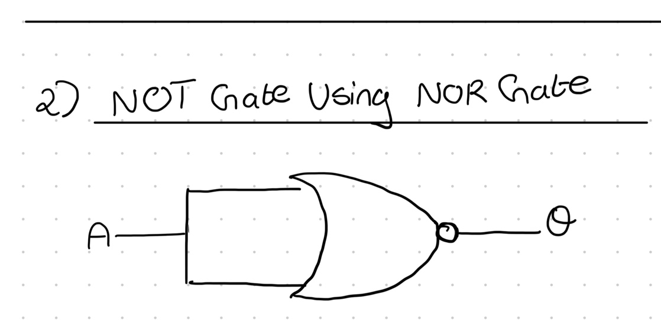

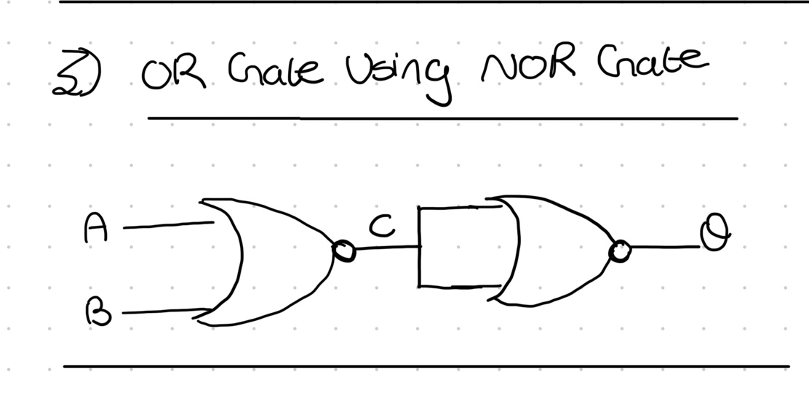

Problem 3 (10 pts)
Consider three input bits x, y, z. Write the following four Boolean logic functions F_{i}(x, y, z), i = 1, 2, 3, 4, described as follows.
1. F₁(x, y, z) = 1 if (x, y, z) contains only a single 0.

F₁(x, y, z) = (x ​• y ​• ̄z) + (x ​• ̄y ​• z) + (̄x ​• y ​• z)
2. F₂(x, y, z) = 1 if (x, y, z) contains an even number of 0’s.

F₂(x, y, z) = ̄x ⊕ ̄y​ ⊕ ̄z​
3. F₃(x, y, z) = 1 if (x, y, z), interpreted as an unsigned binary number, is less than 4.

F₃(x, y, z) = ̄x • ̄y​ • z̄ + ̄x • ̄y ​• z + ̄x • y • ̄z + ̄x • y • z
4. F₄(x, y, z) = 1 if (x, y, z), interpreted as a signed two’s complement binary number, is negative.

F₄(x, y, z) = x

- Function F_{i} returns 0 otherwise, (i.e. if its stated condition is not met).

Problem 4 (10 pts)
Construct the four functions described in Problem 3 into a PLA.

x | y | z | F₁
0 | 0 | 0 | 0
0 | 0 | 1 | 1
0 | 1 | 0 | 1
0 | 1 | 1 | 1
1 | 0 | 0 | 1
1 | 0 | 1 | 1
1 | 1 | 0 | 1
1 | 1 | 1 | 0

x | y | z | F₂
0 | 0 | 0 | 1
0 | 0 | 1 | 0
0 | 1 | 0 | 0
0 | 1 | 1 | 1
1 | 0 | 0 | 0
1 | 0 | 1 | 1
1 | 1 | 0 | 1
1 | 1 | 1 | 0

x | y | z | F₃
0 | 0 | 0 | 1
0 | 0 | 1 | 1
0 | 1 | 0 | 1
0 | 1 | 1 | 1
1 | 0 | 0 | 0
1 | 0 | 1 | 0
1 | 1 | 0 | 0
1 | 1 | 1 | 0

x | y | z | F₄
0 | 0 | 0 | 0
0 | 0 | 1 | 0
0 | 1 | 0 | 0
0 | 1 | 1 | 0
1 | 0 | 0 | 1
1 | 0 | 1 | 1
1 | 1 | 0 | 1
1 | 1 | 1 | 1

Problem 5 (10 pts)
Derive (by hand) the product-of-sums (POS) representation for the Boolean function E(A, B, C) shown on page A-11 in the textbook (we also went over in class), starting with the sum-of-products representation. You will need to apply DeMorgan’s laws. For convenience, E is the function that outputs 1 when (A, B, C) contains exactly two ones.

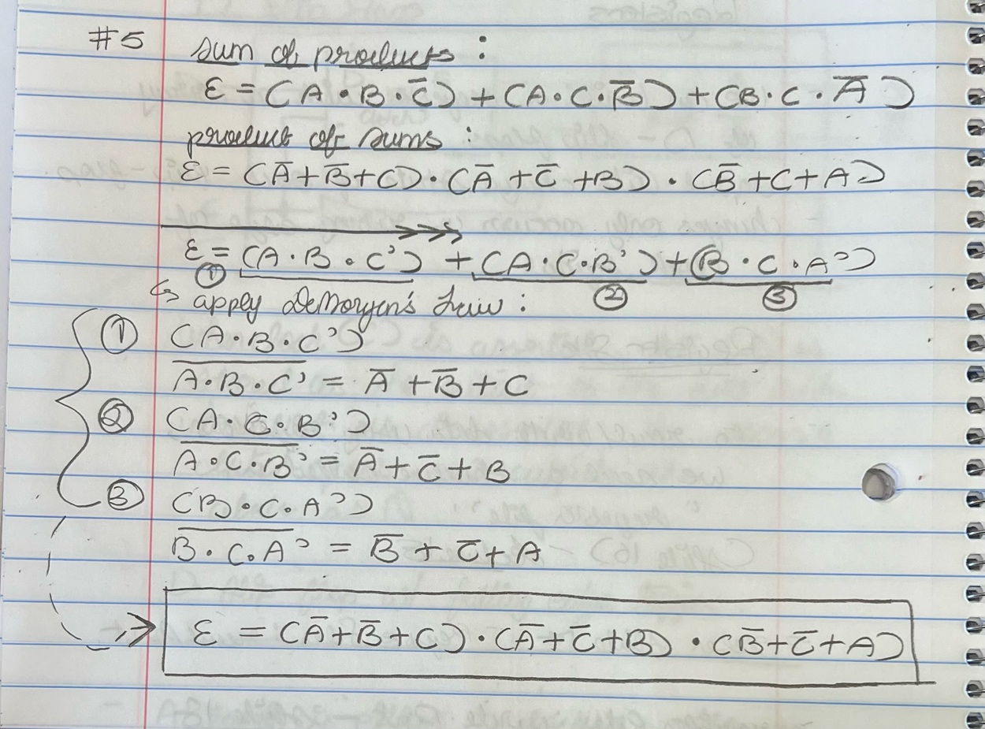

Bonus problem (10 pts)
Implement a “switching network” function that takes three inputs A, B, and S, and gives two outputs C and D. Input S is the control signal: if S = 1, then C = A and D = B. If S = 0, then C = B and D = A. Create the truth table and draw a block diagram.

A | B | S | C | D
0 | 0 | 0 | 0 | 0
0 | 0 | 1 | 0 | 0
0 | 1 | 0 | 1 | 0
0 | 1 | 1 | 0 | 1
1 | 0 | 0 | 0 | 1
1 | 0 | 1 | 1 | 0
1 | 1 | 0 | 1 | 1
1 | 1 | 1 | 1 | 1

